Practical - 7
Practical Title: PHP Form Processing with Server-Side Validation and CSV/JSON File Storage
Problem Definition: Process submitted registration/contact form data using PHP. Validate and sanitize inputs on the server side and store records in CSV or JSON file format. Display success/error messages.
Theory:
- Is the form submitted using POST?
Ans: Yes, the form uses method="POST" in the HTML tag, and the backend verifies the request using $_SERVER["REQUEST_METHOD"] == "POST".
- Are inputs validated and sanitized server side?
Ans: Yes, inputs are cleaned using trim() to remove excess spaces, checked with empty() to prevent blank submissions, and validated before any data is processed.
- Is file writing handled safely?
Ans: Yes, JSON writing decodes existing entries before appending new data, and the CSV file is safely opened in append mode ("a") using fputcsv() and properly closed with fclose().
- Are success and error responses displayed clearly?
Ans: Yes, user feedback is stored in a $message variable and displayed directly above the form in distinct red (for errors) or green (for success) text.
Implementation/ Output/Result :
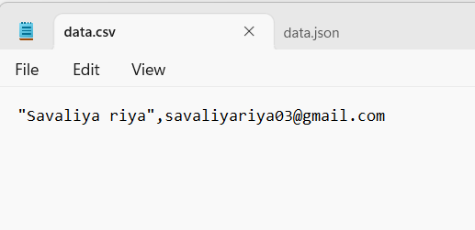

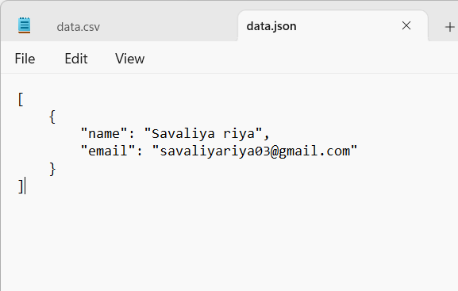
- GitHub Repository Link:
StudentHub/PHP at main · savaliyariya03/StudentHub
- Challenges Faced:
Handling dual-format file operations safely so existing data was preserved when appending new records to both JSON and CSV files, along with managing server-side input sanitation before storage.

- Learning Outcomes:
Gained hands-on experience handling HTTP POST requests in PHP, implementing server-side validation, and safely persisting structured form data into file formats using functions like json_encode() and fputcsv().

- Faculty Remarks:

